Detailed instructions for
SunSmart Renewals
(ECH, OSHC and Primary Schools)

CONTENTS | PAGE
Logging in | 2-5
The home page  Can’t find your organisation in the search menu?  Forgot your password? | 2  3  5
Renewing | 6-32
Renewing for ECH Services:  Using your own policy  Using Cancer Council’s policy | 7-17  11  13
Renewing for OSHC Services: | 18-23
Renewing for Primary School Services:  Using your own policy  Using Cancer Council’s policy | 24-32  27  30

- Type in www.sunsmartnsw.com.au into your browser. You should come to the page below.
- Click ‘Get Started’
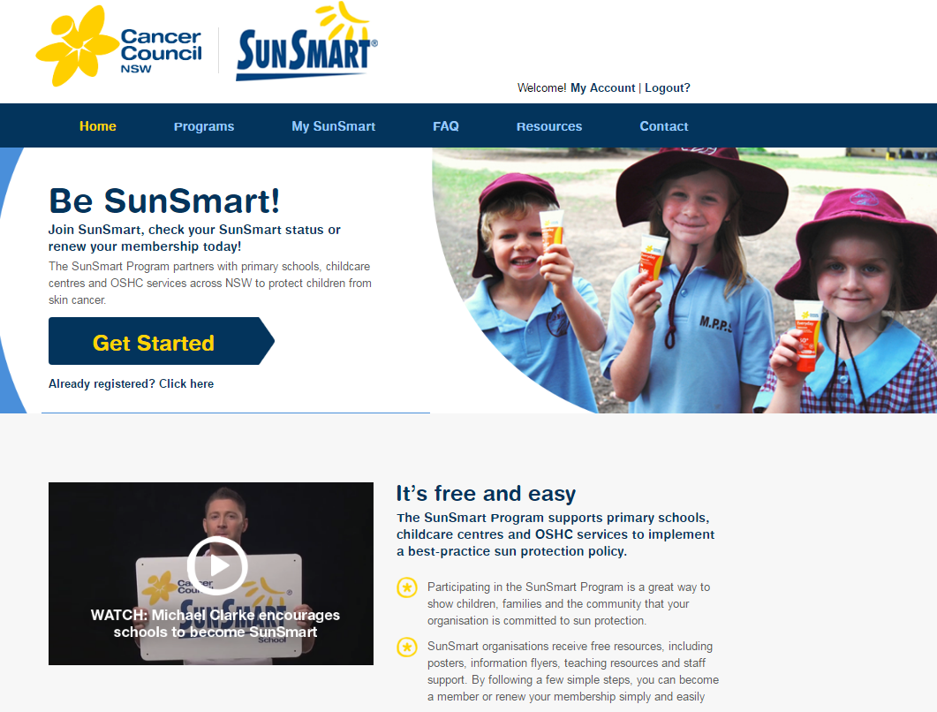
Click
- You should then be on this page:
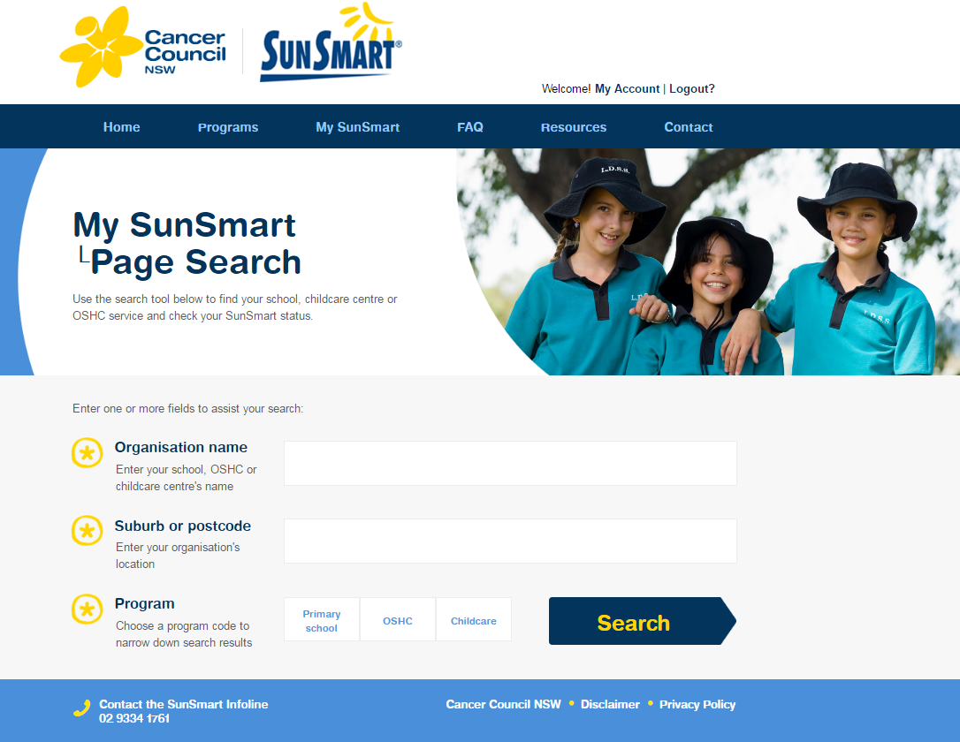

- Type in your service’s name.
- If your service does not come up, type in just one key word of your service name and select your service from the list.
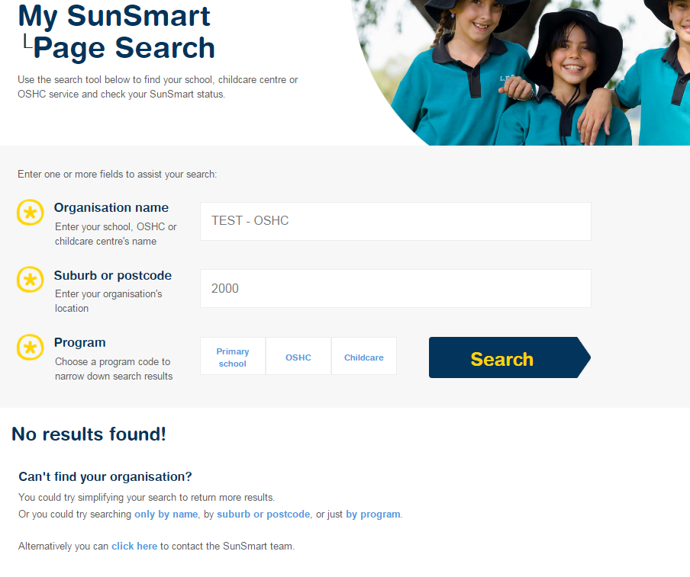
If your service does not show up, try only typing in one key word into “Organisation Name” and no Postcode or Program into the search engine.

- Click on the name of your organisation under the “Select your Organisation” heading
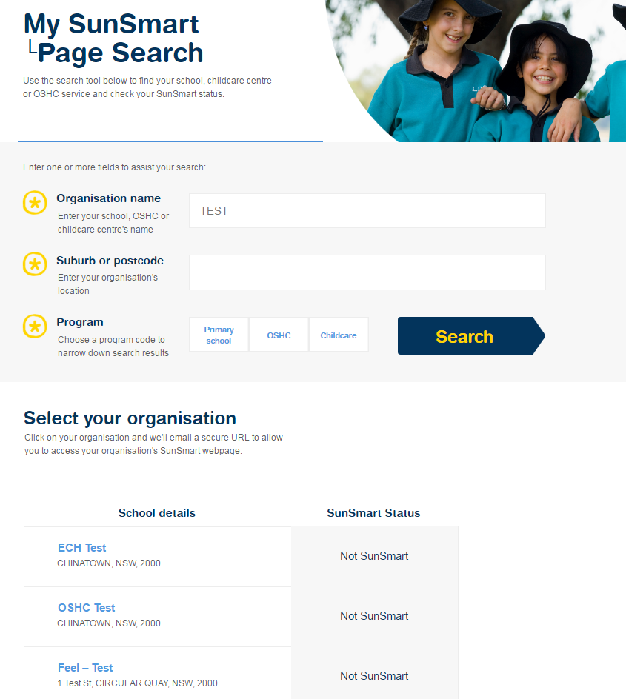
By putting just one key word into the search engine, you can now select your service from the list.

- This will take you to your login page:
- If you can’t remember your password, click ‘Forgot Password’. An email will be sent to you with a temporary password. Once you have logged in with this password, you will be prompted to change your password.
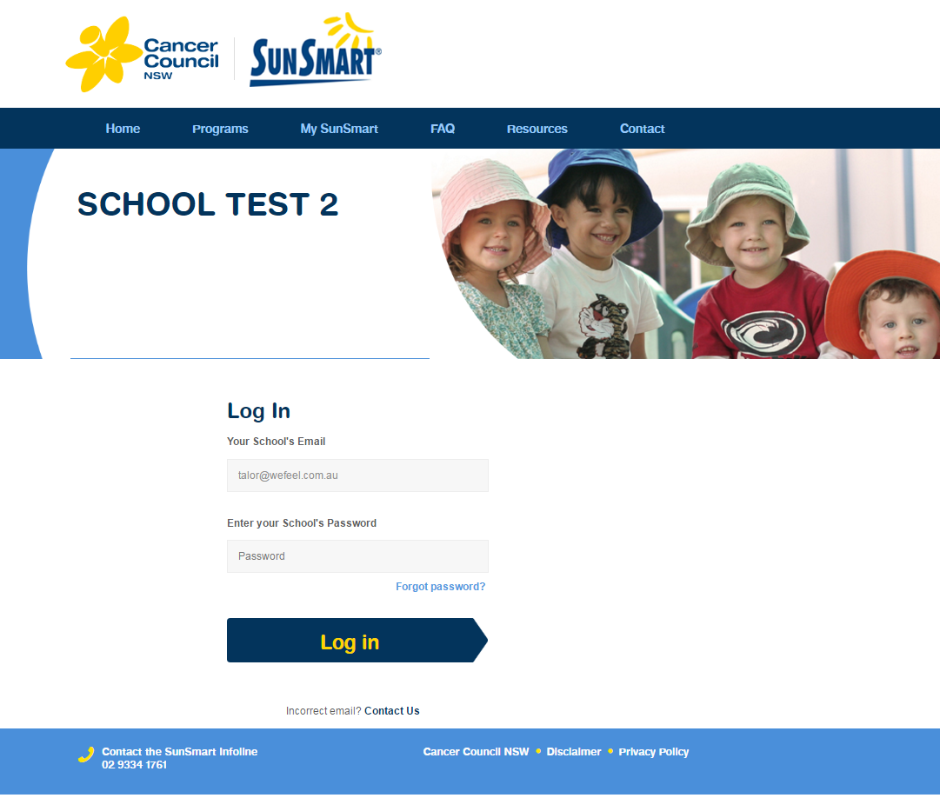
If you have forgotten your password, click here
Once you have entered your email and password, click ‘Log in’

- If your account handles multiple organisations, you then be taken to a page which looks like this. You will have to click the name of the organisation which you would like to renew.
If you only have one organisation, then skip to step 10.
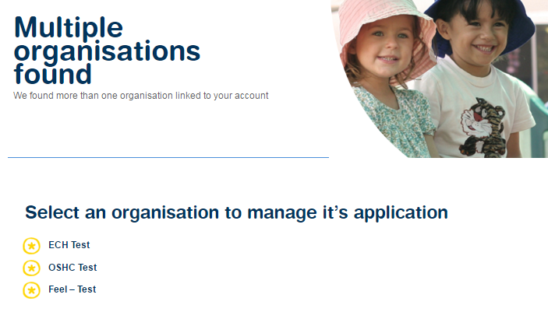
Please go to:
Page 7 for Early Childhood renewal instructions
Page 19 for Out of School Hours Care renewal instructions
Page 24 for Primary School renewal instructions

. Early Childhood Services
10a. If you run an ECH organisation, you will be taken to this page. Click ‘Continue’.
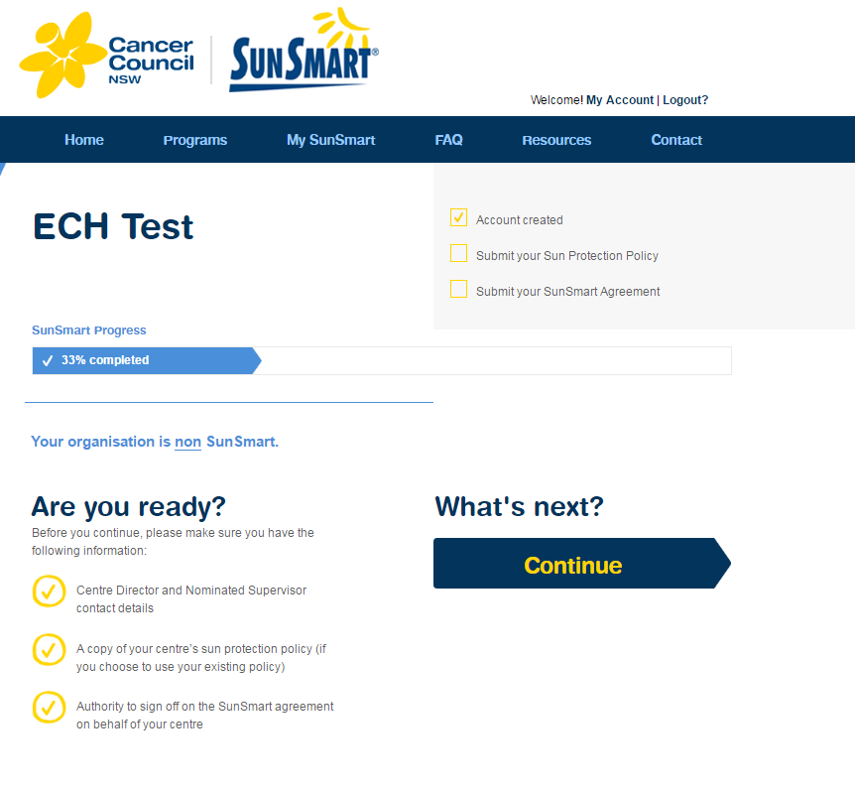

10b. You will then come to this page.
Read each of the best practice SunSmart recommendations and click on ‘Implementing’ to show your organisation is performing each one.
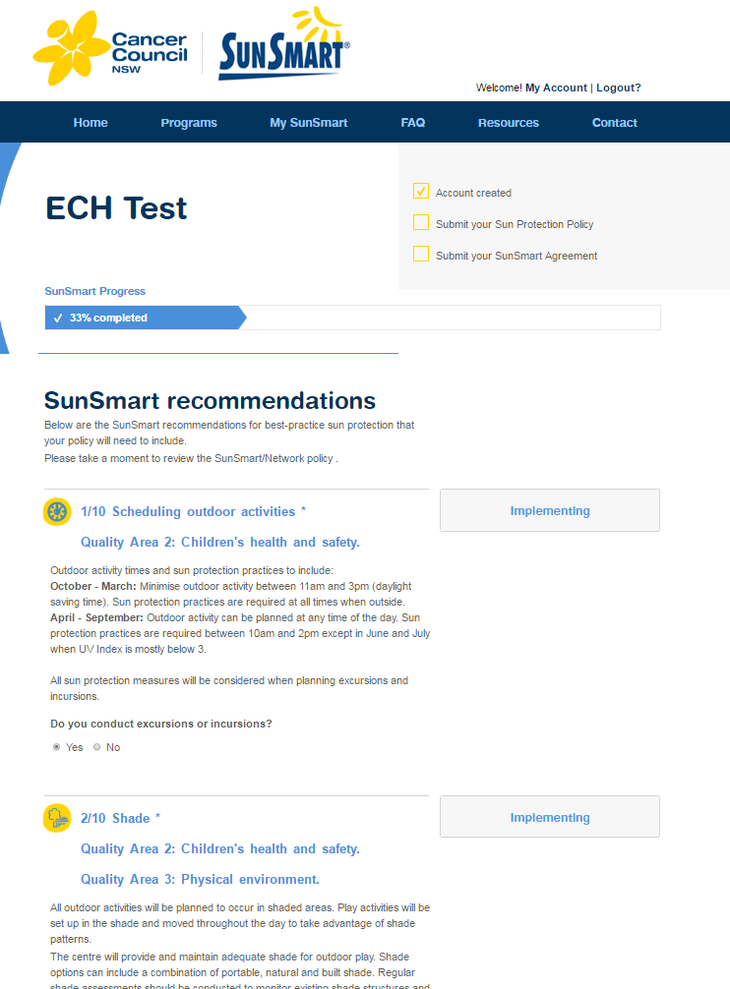
Click

10b.1. When you have clicked ‘Implementing’, they will go blue, as seen here. Then click ‘Continue’.
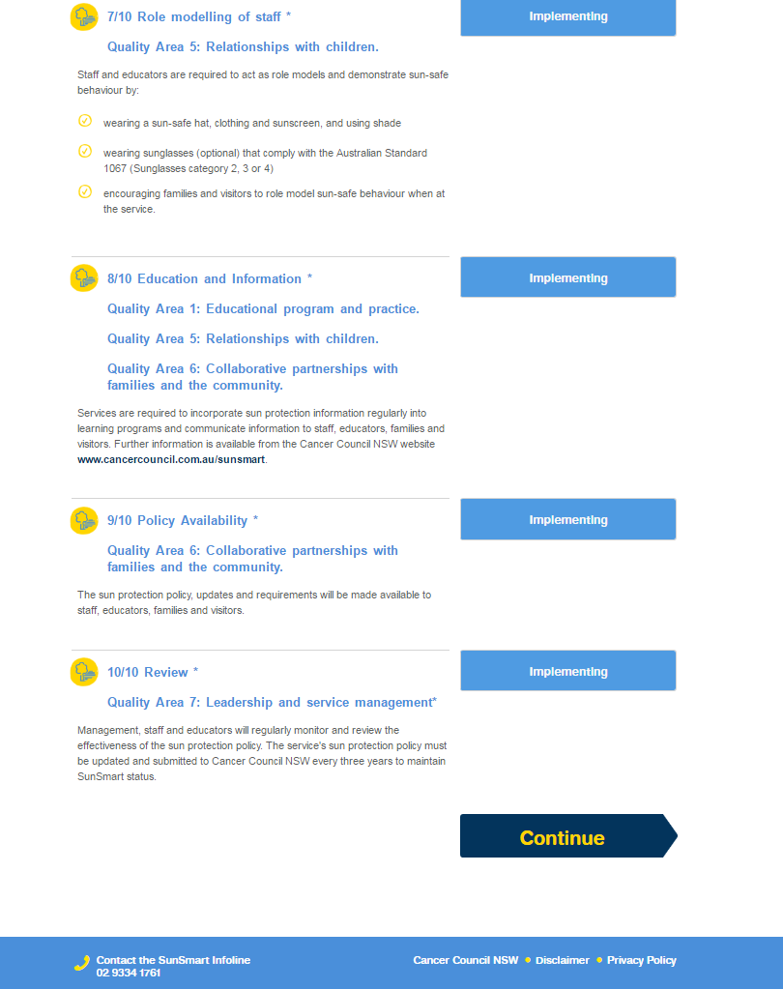
Click

10c. You will then see the page below. You will have an option to adopt Cancer Council NSW’s policy, or upload your own Policy.
- If you wish to upload your own policy then stay on this page.
- If you wish to use Cancer Council NSW’s policy then go to page 13.

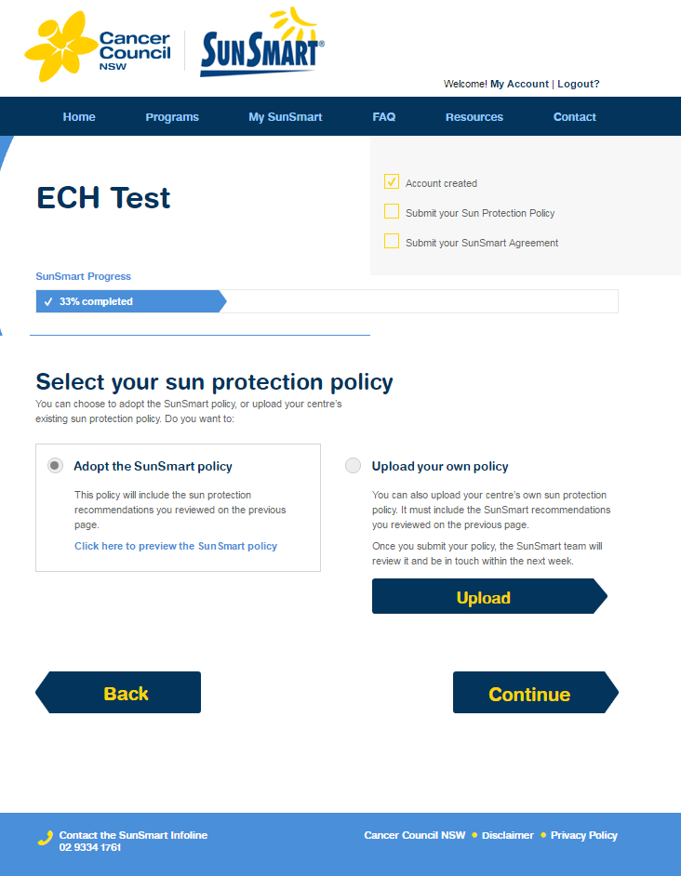

10c.1. To upload your own policy, please click ‘Upload your own policy’
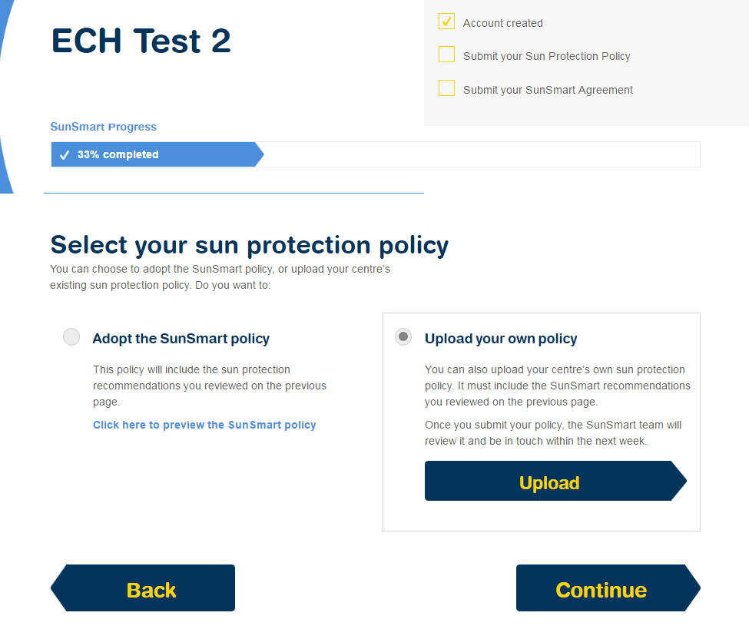
✔

10c.2. You will need to select the file from your computer and click ‘Open’.
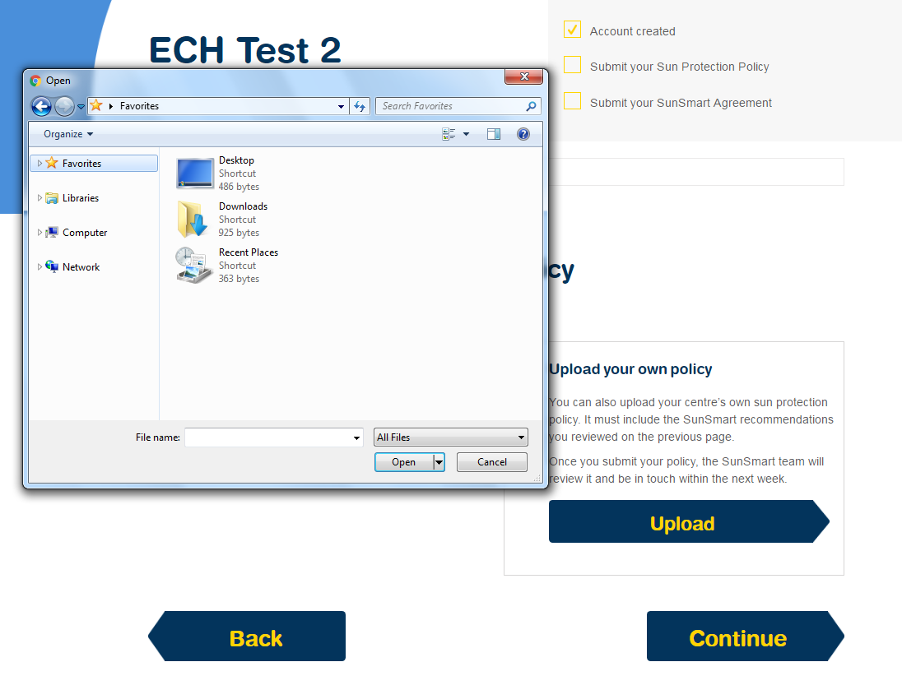
Locate the file in your computer and click ‘Open’

10c.3. Once you have chosen a file, you will see ‘File Selected: Name of File’ under ‘Upload your own policy’. Then click ‘Continue’.
- Please go to Page 15 for the last step of the renewal process
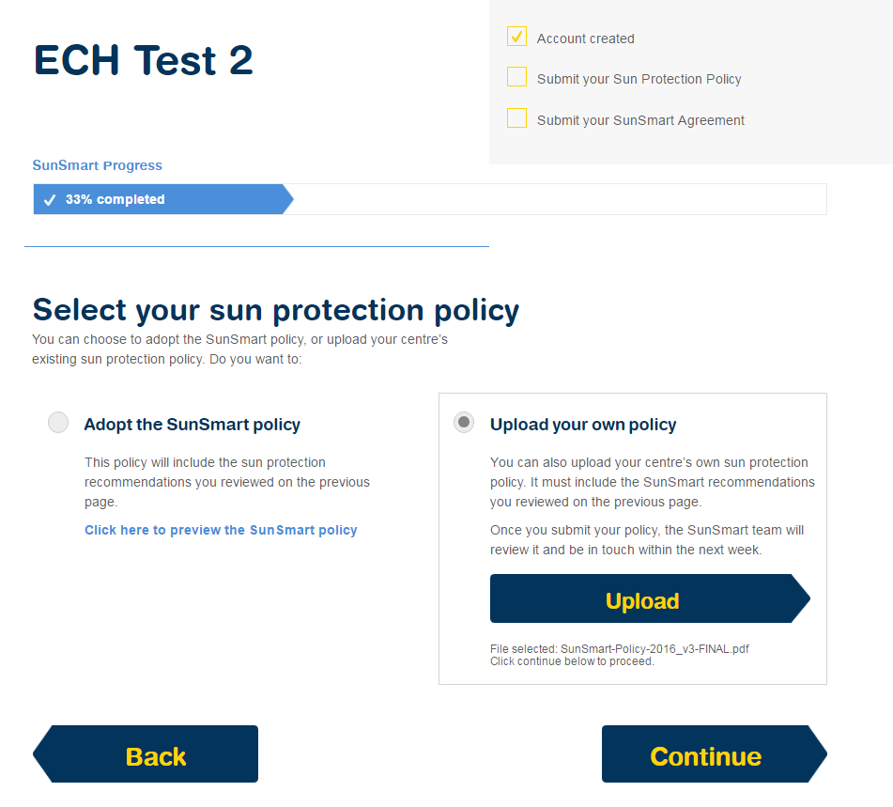
Click

10d. If you wish to use Cancer Council NSW’s SunSmart policy, please check the ‘Adopt the SunSmart Policy’ box. Then Click ‘Continue’.
Click
✔

10e. The final stage of renewing is filling in your contact details. Fill in the details of the centre director below where it says “On behalf of the Centre Director”
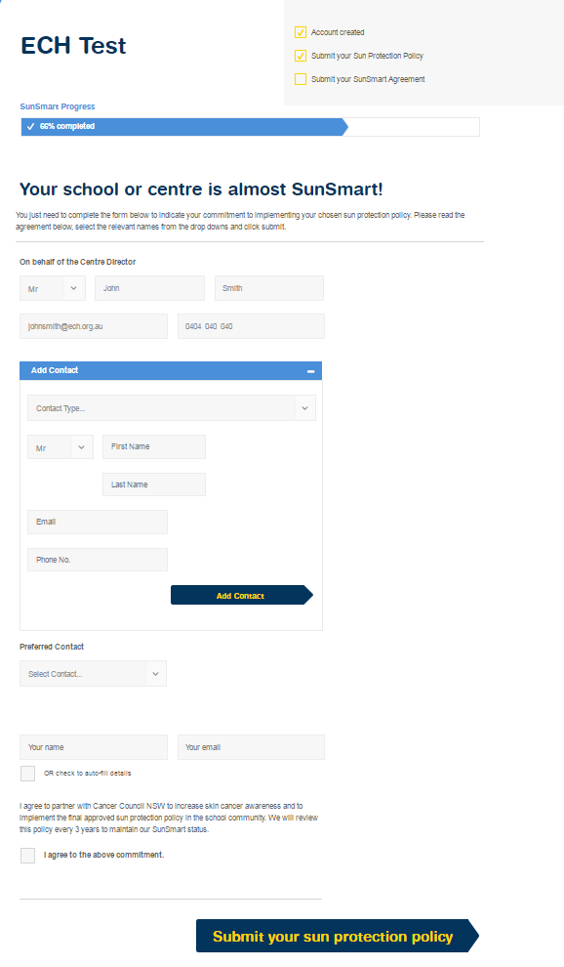
Fill in the details of anyone else you wish to include in here and then click ‘Add Contact’
Fill in your Centre Director’s details in here

10e.1. Once you have filled in the details of your Centre Director you can also add in the details of another contact, such as the centre Supervisor. Then click ‘Add Contact’.
Your page should now look like this.
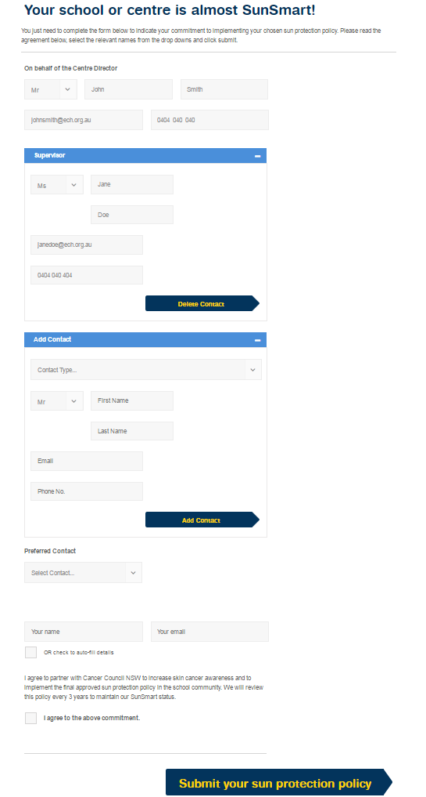

10e.2. If you have entered two contacts, click ‘Preferred Contact’ and select one of the two people whose details you have entered.
Then fill in Your Name and Your Email, check the box ‘I agree to the above commitment’ and click ‘Submit your Sun Protection Policy’ and your renewal will be completed!

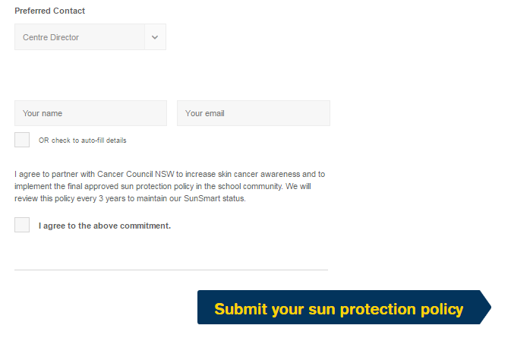
4

3

2

1

Click
✔

Finished!

11. OSHC
11a. Once you have logged in to an OSHC organisation, you should come to this page. Click ‘Continue’.
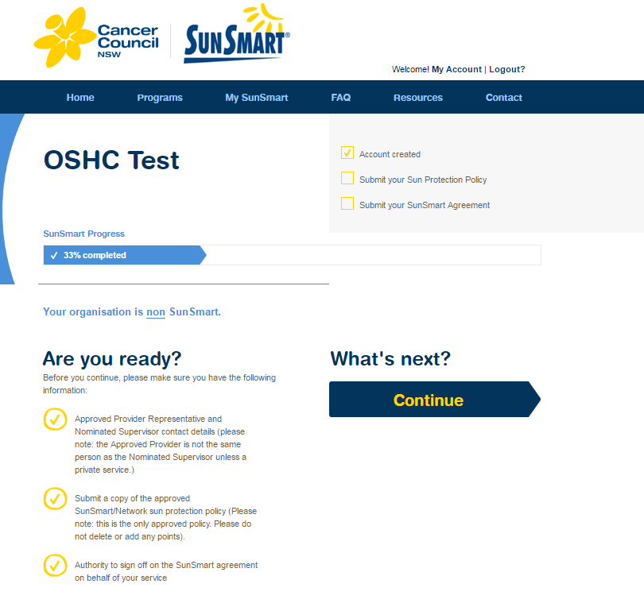
Click

11b. Read each of the best practice SunSmart recommendations and click on ‘Implementing’ to show your organisation is performing each one.

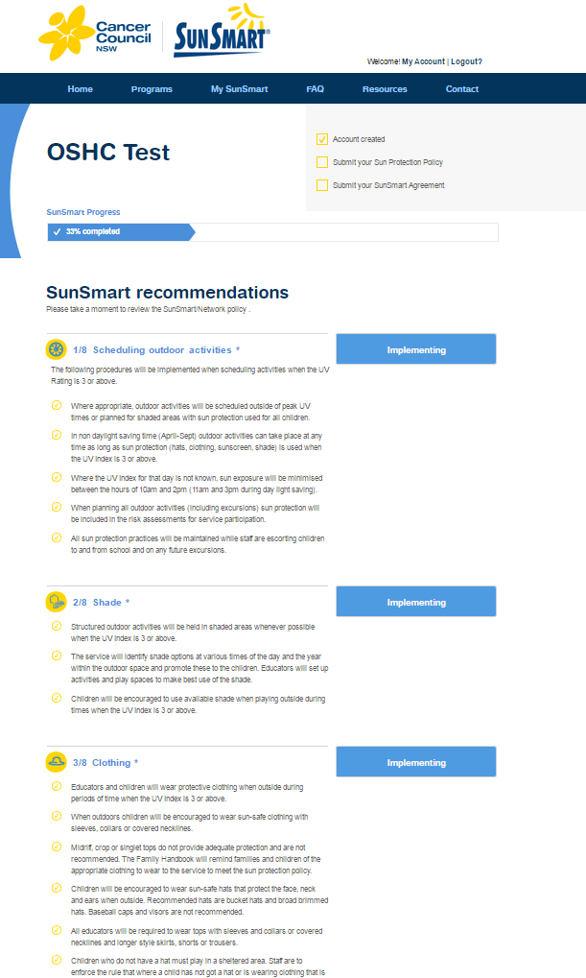
Click

11b.1. Once you have clicked ‘Implementing’ on all of the recommendations, click ‘Continue’.
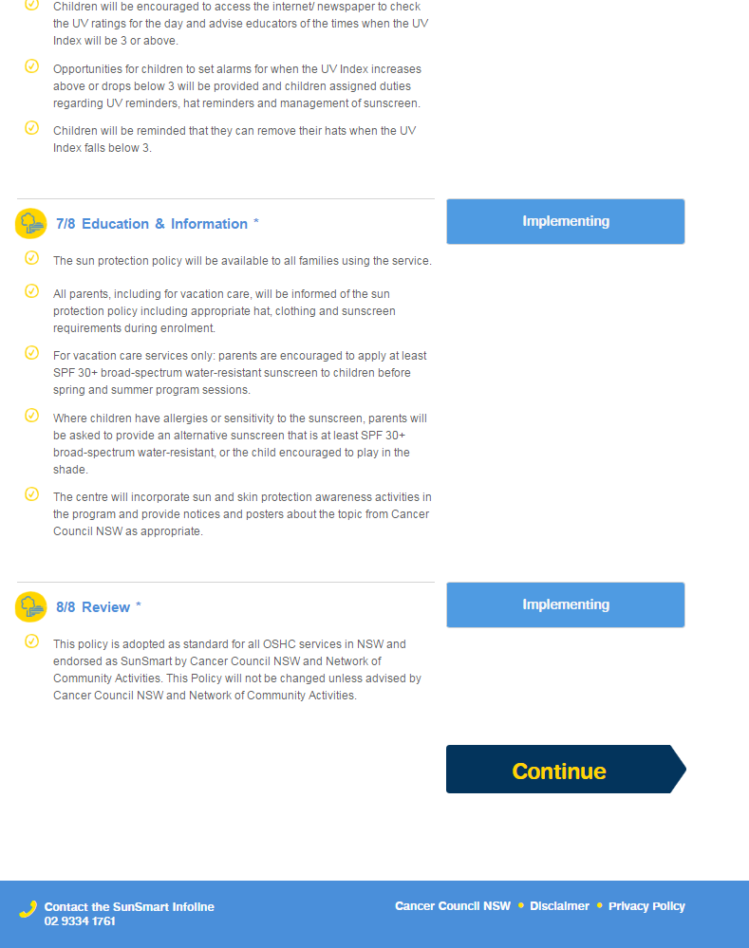
Click

11c. You will then need to check the box of ‘Adopt the SunSmart Policy’ and click ‘Continue’
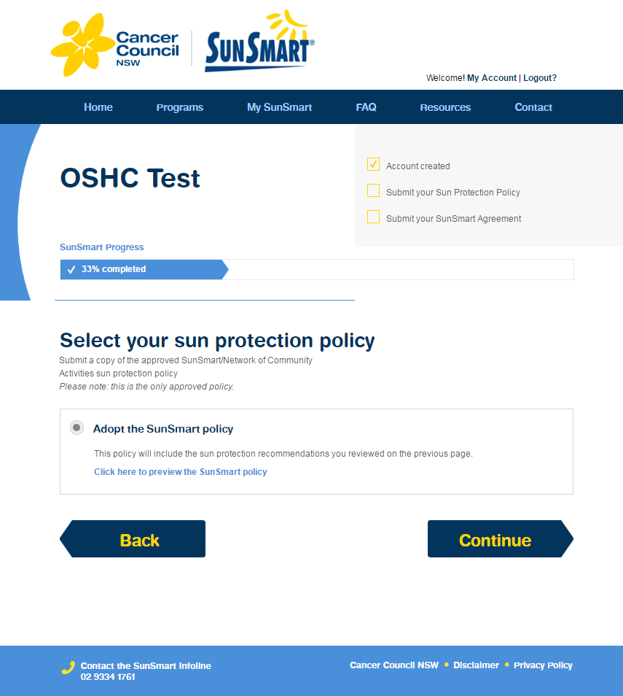
Click
✔

11d. The last stage of your renewal is entering your organisations’ contact details. You will need to enter details of both your Nominated Supervisor and the Approved Provider.
*Please note that these are two separate contacts with two separate emails (unless you are a privately owned service).
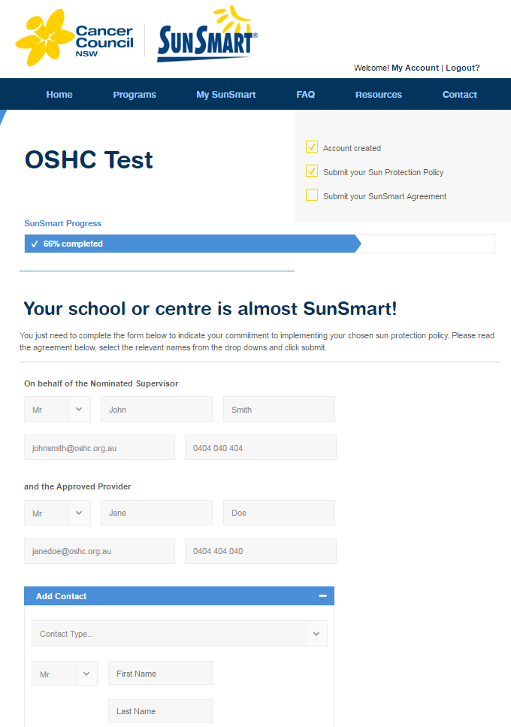
Fill in your Approved Provider’s details in here
Fill in your Nominated Supervisor’s details in here

11d.1. You will then need to select your Preferred Contact from those you have entered, then enter Your Name and Your Email, and finally check the box saying ‘I agree to the above commitment’. Then click ‘Submit your Sun Protection Policy’ and your renewal will be complete!
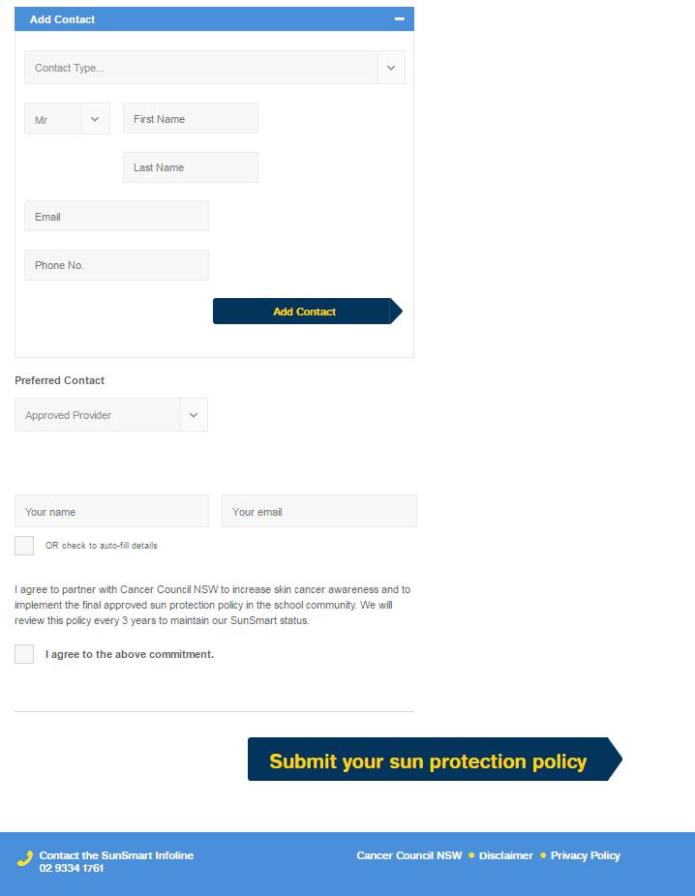
1

2

3

5

4

Fill in the details of anyone else you wish to include in here and then click ‘Add Contact’
Click
✔

Finished!

12 PRIMARY SCHOOLS
12a. Once you have logged in, you should see a page which looks like this. Click ‘Continue’.
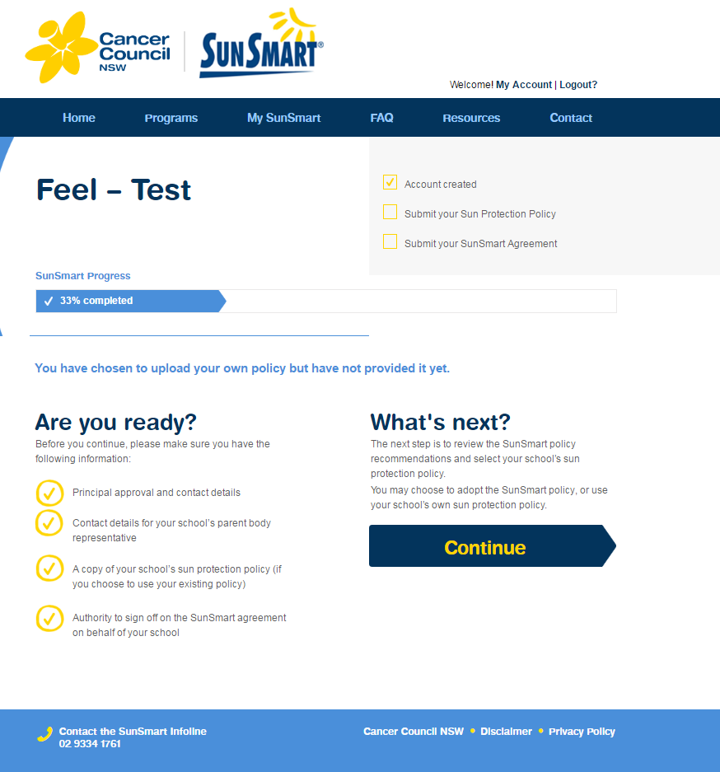
Click

12b. You will then come to this page.
Read each of the best practice SunSmart recommendations and click on ‘Implementing’ or ‘Planning’ to show your organisation is performing each one. Once you have clicked, that box will turn blue, as shown below.
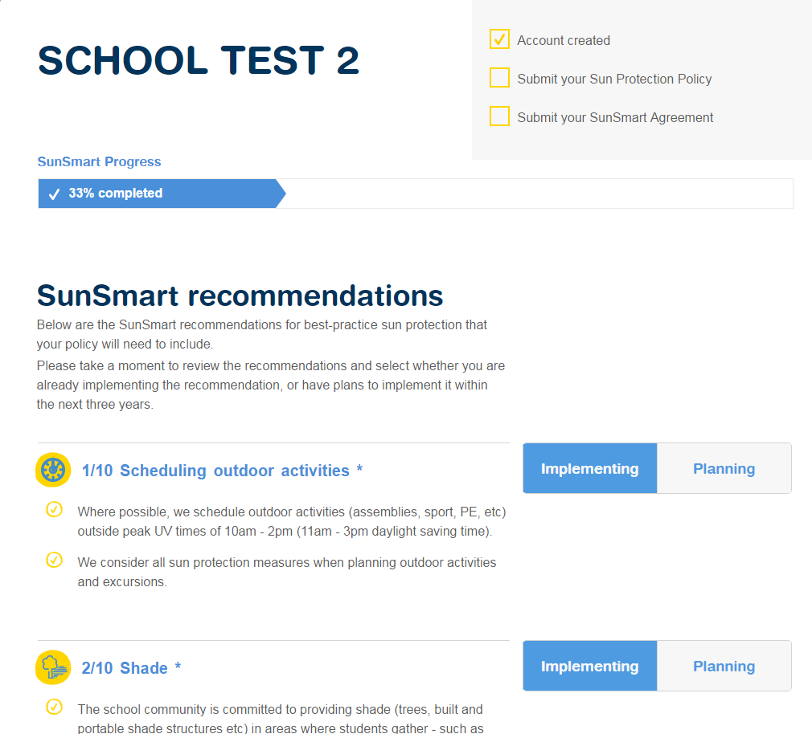
Click

12b.1. Once you have clicked whether your school is ‘Implementing’ or ‘Planning’ each of the recommendations, click ‘Continue’
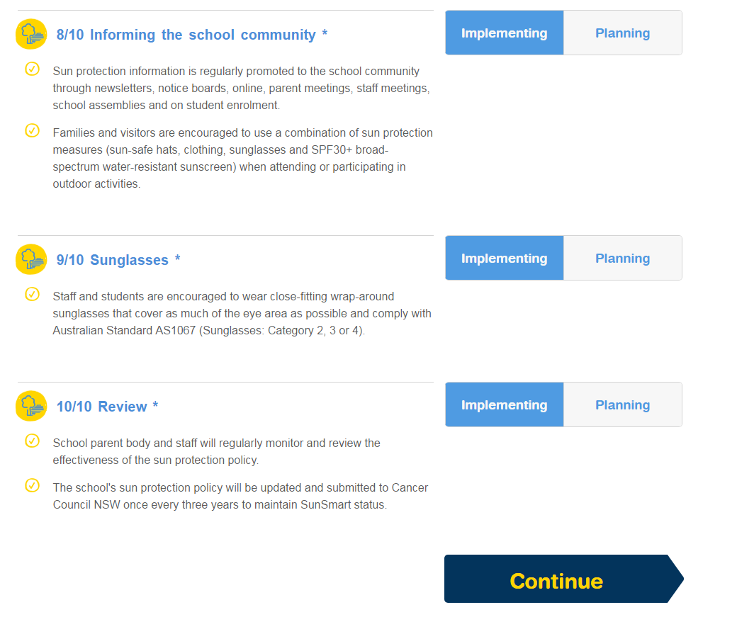
Click

12c. You can then choose whether you will use Cancer Council NSW’s SunSmart Policy, or use your school’s own policy.
- If you wish to adopt Cancer Council NSW’s policy, go to page 31.
- If you wish to upload your own Policy, please continue to the next page.
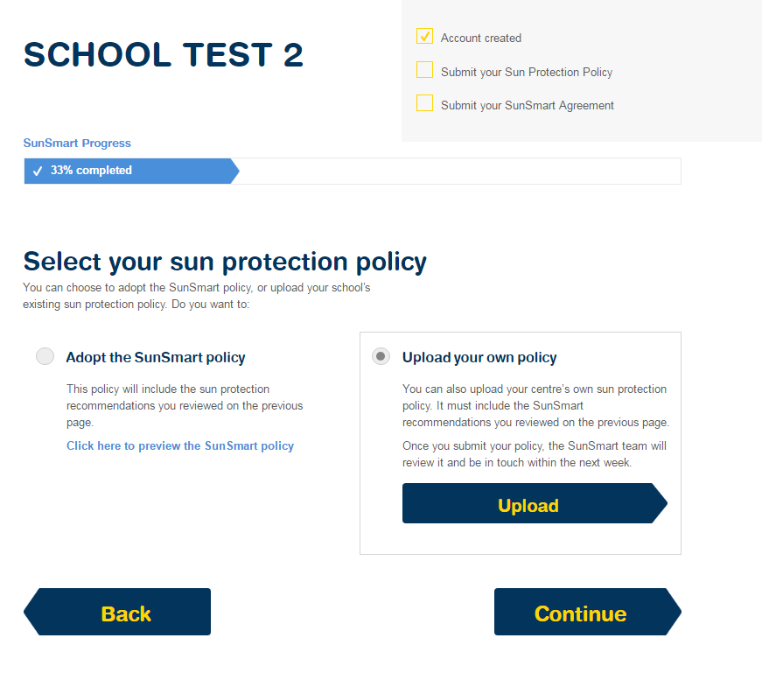
✔

12d. To upload a custom policy: Once you have selected ‘Upload’, you will need to find the file in your computer and select ‘open’.
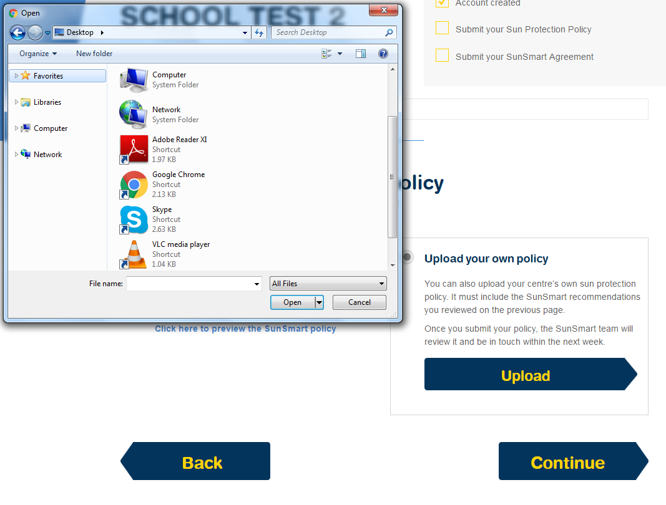

12d.1. Once you have chosen a file, you will see ‘File Selected: Name of File’ under ‘Upload your own policy’. Then click ‘Continue’.
- Please go to Page 32 for the last step of the renewal process.

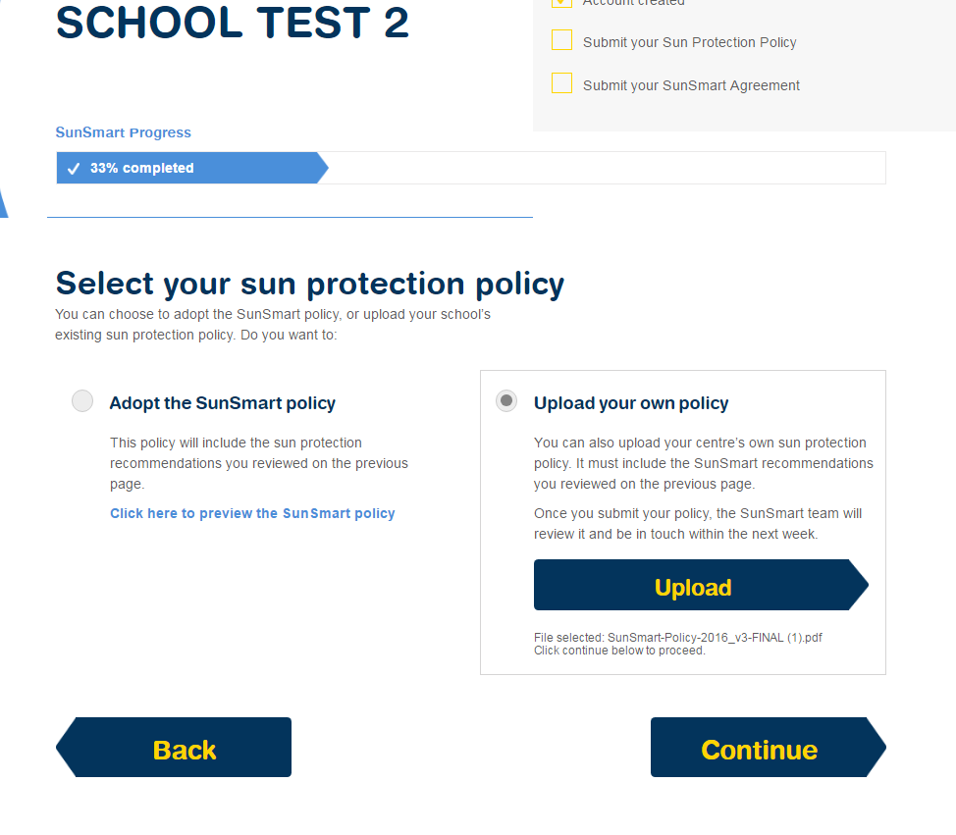
Click

12e. To adopt Cancer Council NSW’s policy, check ‘Adopt the SunSmart Policy’ and click ‘Continue’
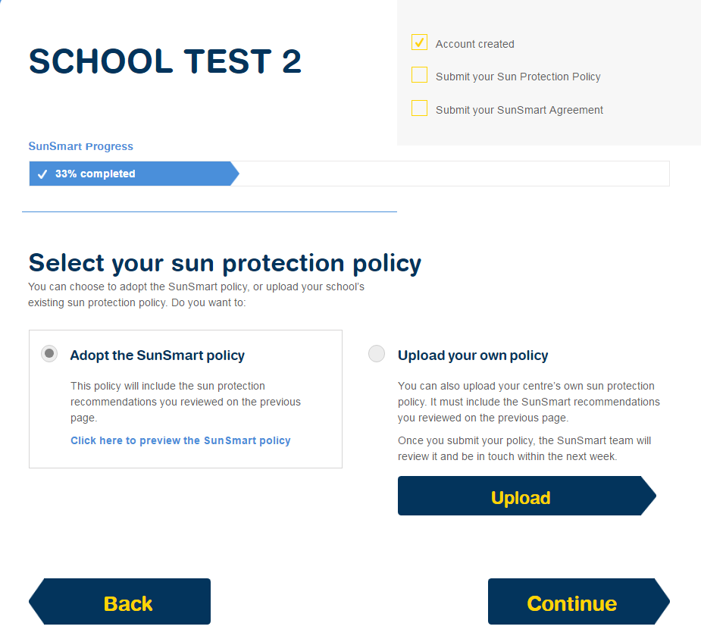
Click
✔

12f. The final stage of the renewal is entering your contact details.
You will need the contact details of both the Principal and the Parent Body Contact.
*Please note that these are two different contacts with two separate emails.
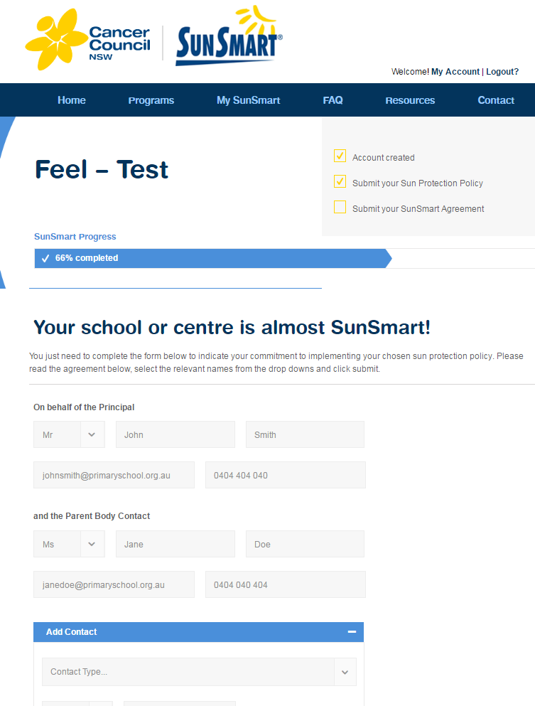
Fill in your Principal’s details in here
Fill in the details of your Parent Body Representative here

12f.1. If there is another person who completes the SunSmart renewals, you can add their details in under ‘Add Contact’.
Then select which of the people you have entered is your school’s Preferred Contact.
Fill in the Your Name and Your Email fields
Finally, you will need to check the box ‘I agree to the above commitment’
Now click ‘Submit your sun protection policy’ and your renewal is complete!
1

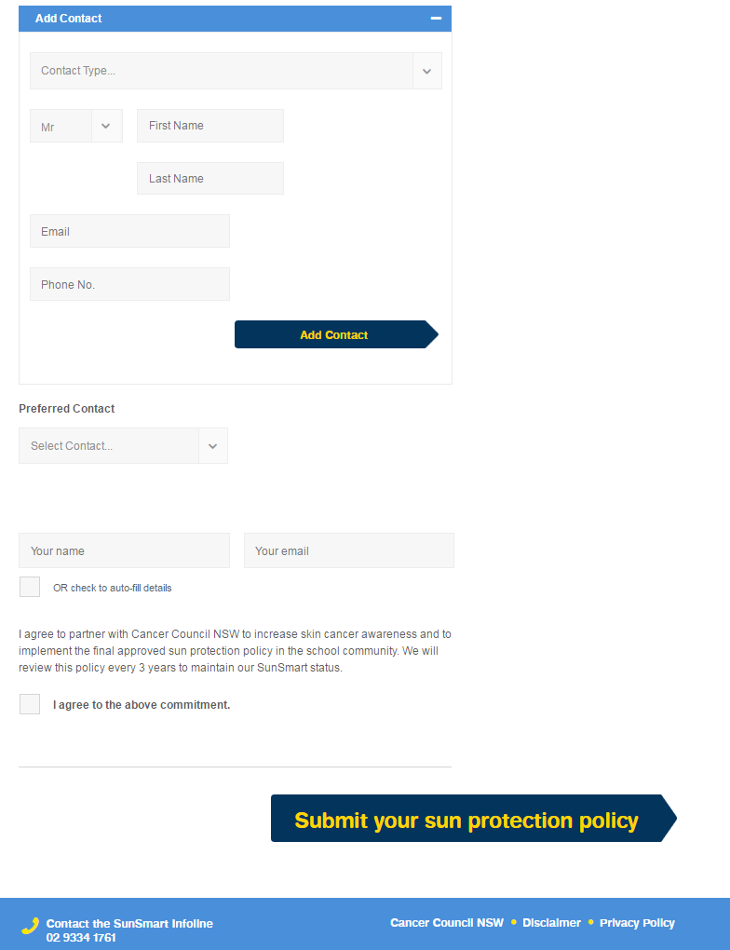
Finished!
5

4

3

2

Fill in the details of anyone else you wish to include in here and then click ‘Add Contact’
Click
✔

